ECE 3300L

Lab 9

Instructor: Dr. Mohamed El-Hadedy

Group A

Joseph Popoviciu & Sami Elias

Objective:

Use PWM to control 2 separate RGB lights. Use a button to select which RGB to change.

Results:

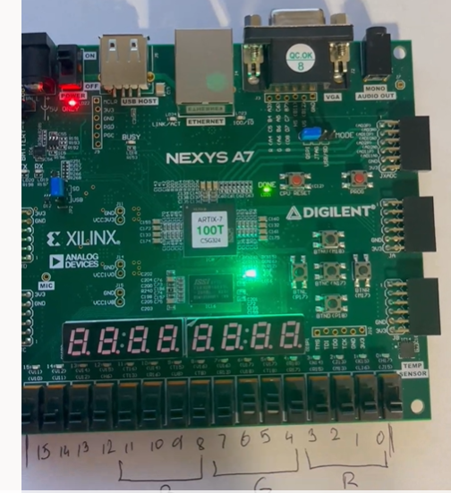

We used a PWM to control the color of the RGB LED and the resolution. The more significant the bit, the higher the resolution. When we press the top black button, we switch to controlling the other RGB LED. Switching to the other RGB LED will not change the color or resolution of the other LED.

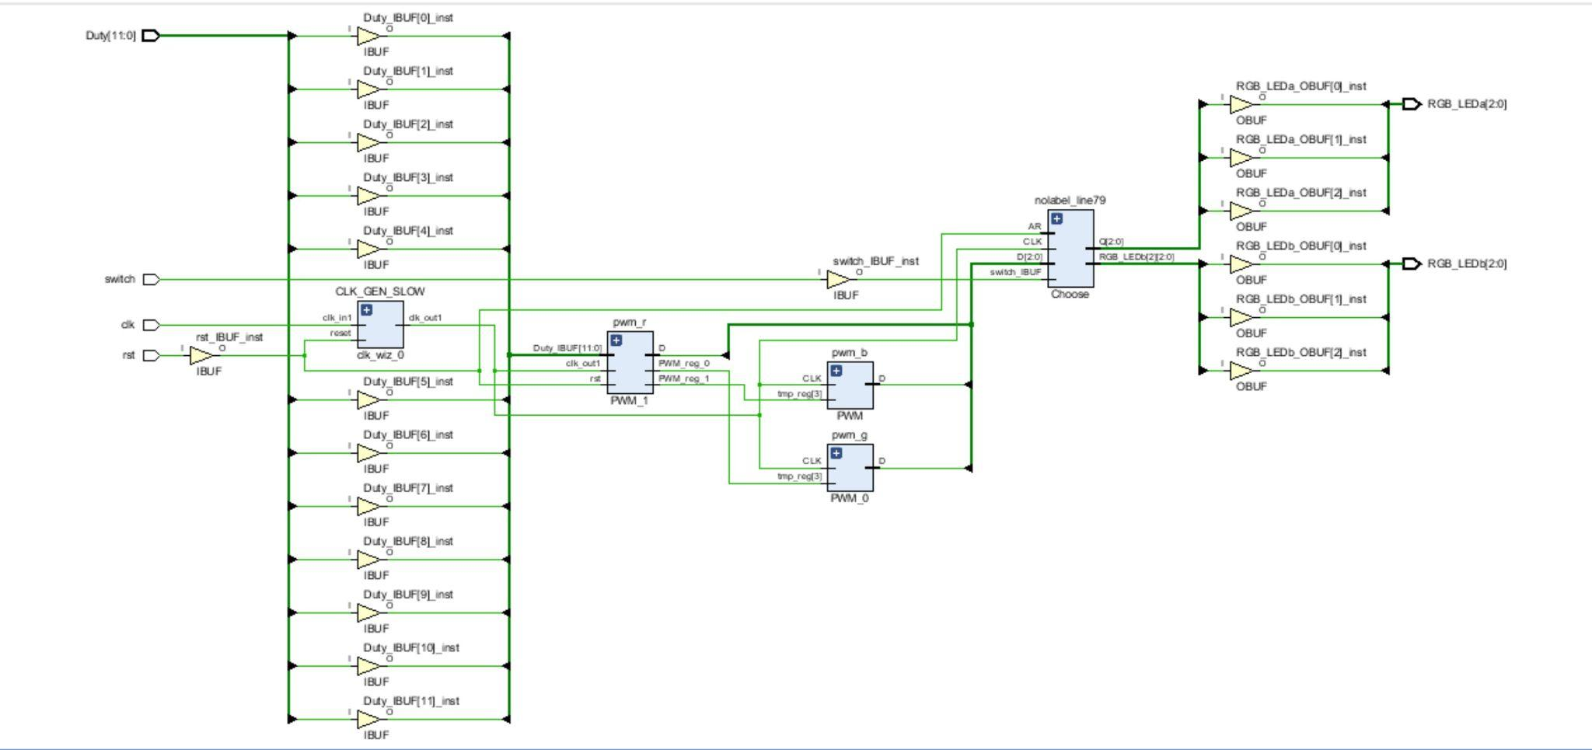

Figure 1 - Schematic

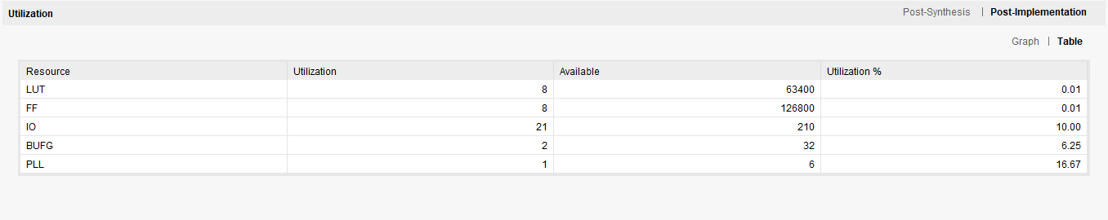

Figure 2 - Utilization

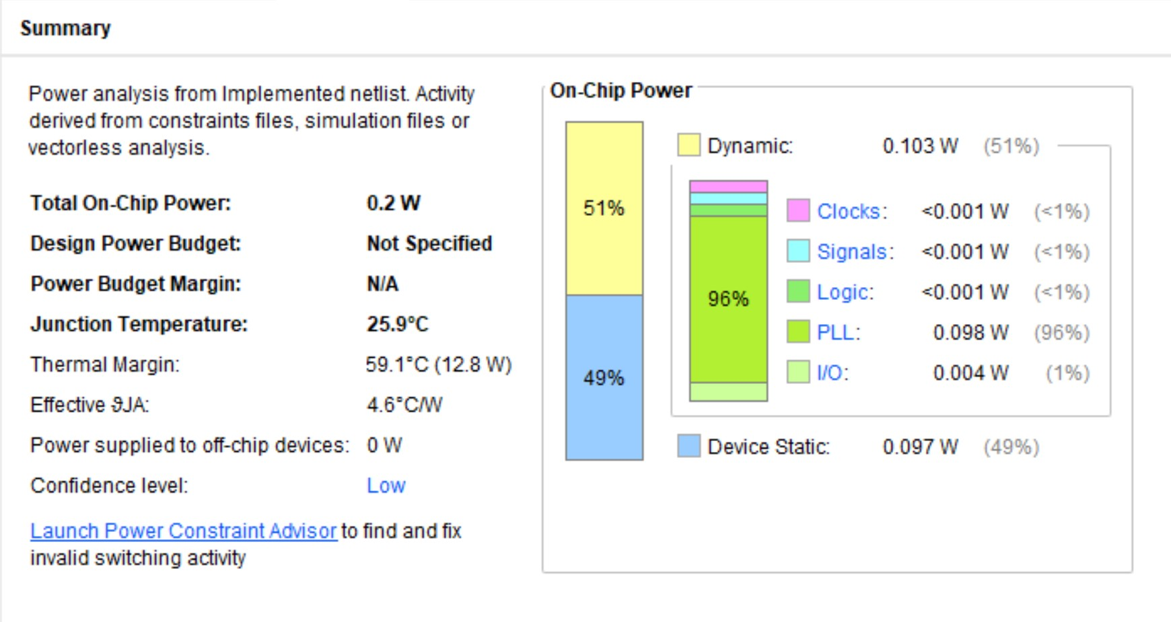

Conclusion:

We learned about the PWM and how to implement it using it to control two different RGB LEDs.